**Lab 9 Deliverables**

Akaash Chikarmane and Milan Feliciello

Section: 16085

Spring 2016

**Oscilloscope Pictures**

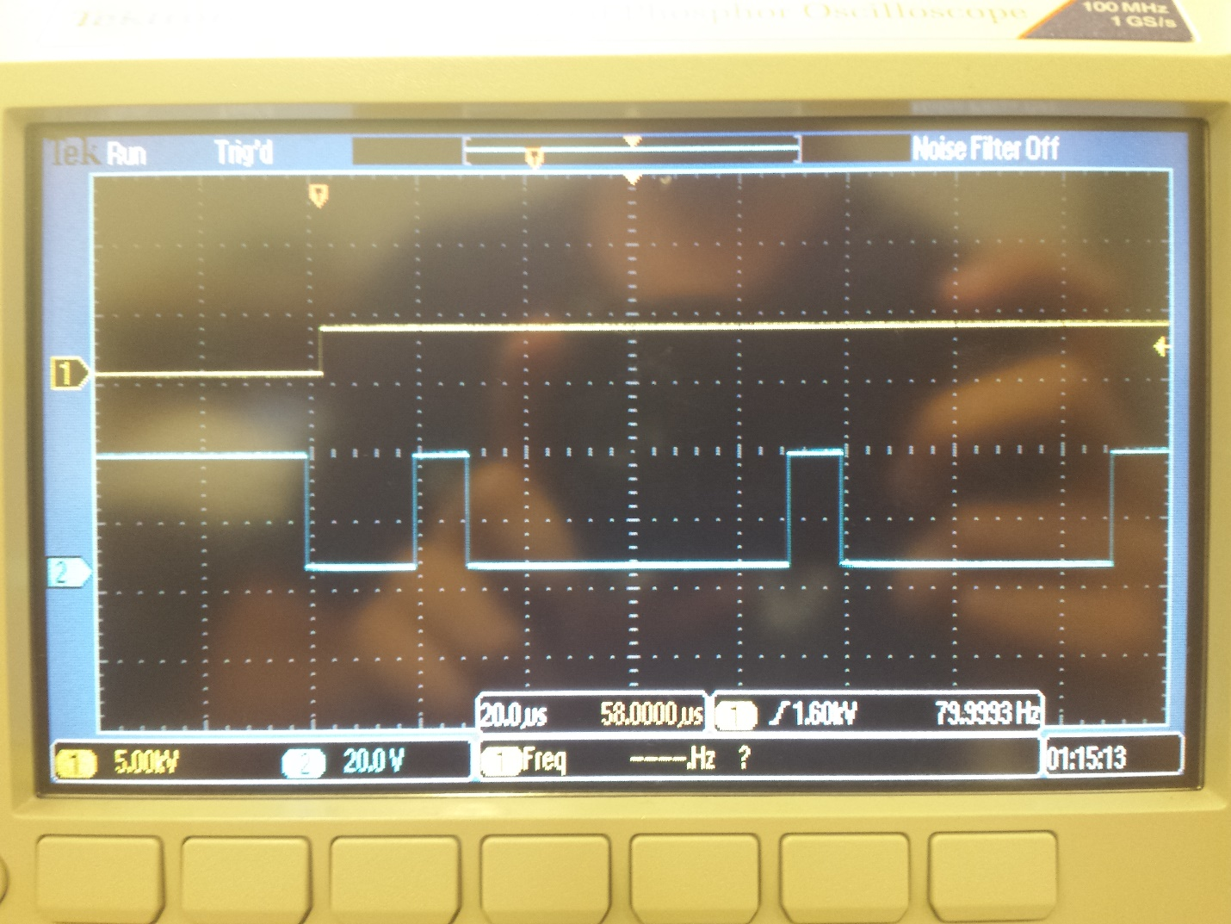

First two frames of the message (transmit)

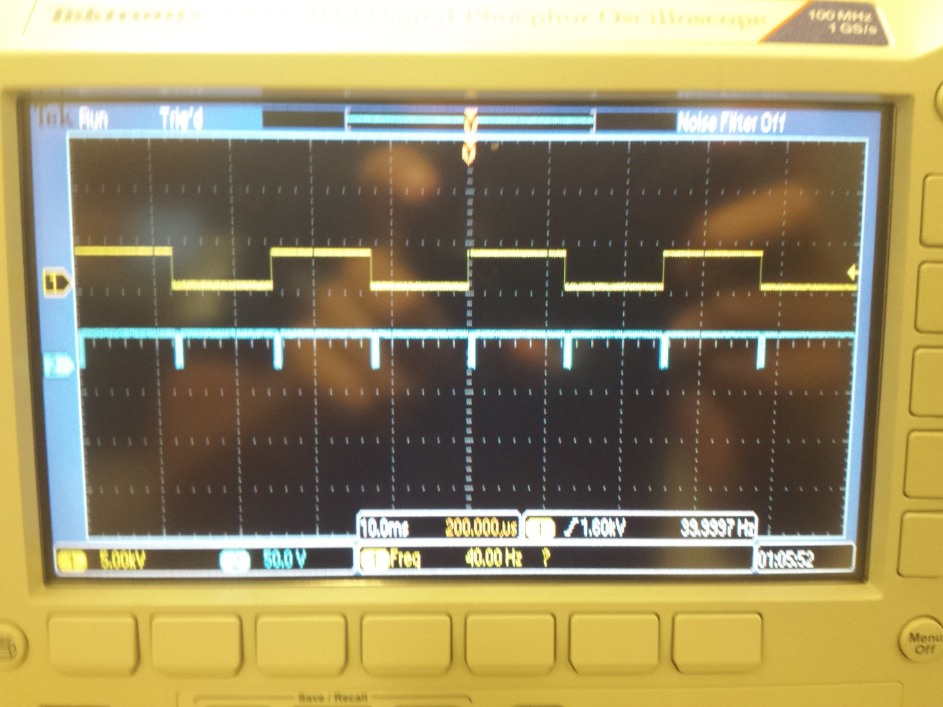

SysTick interrupting at 40 Hz

**Circuit Diagrams**

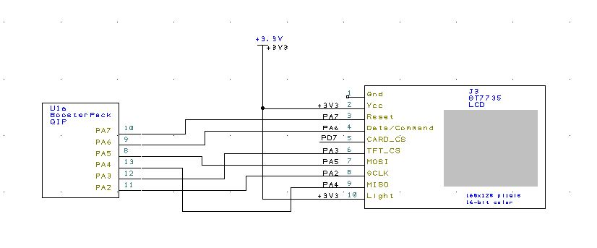

LCD connection

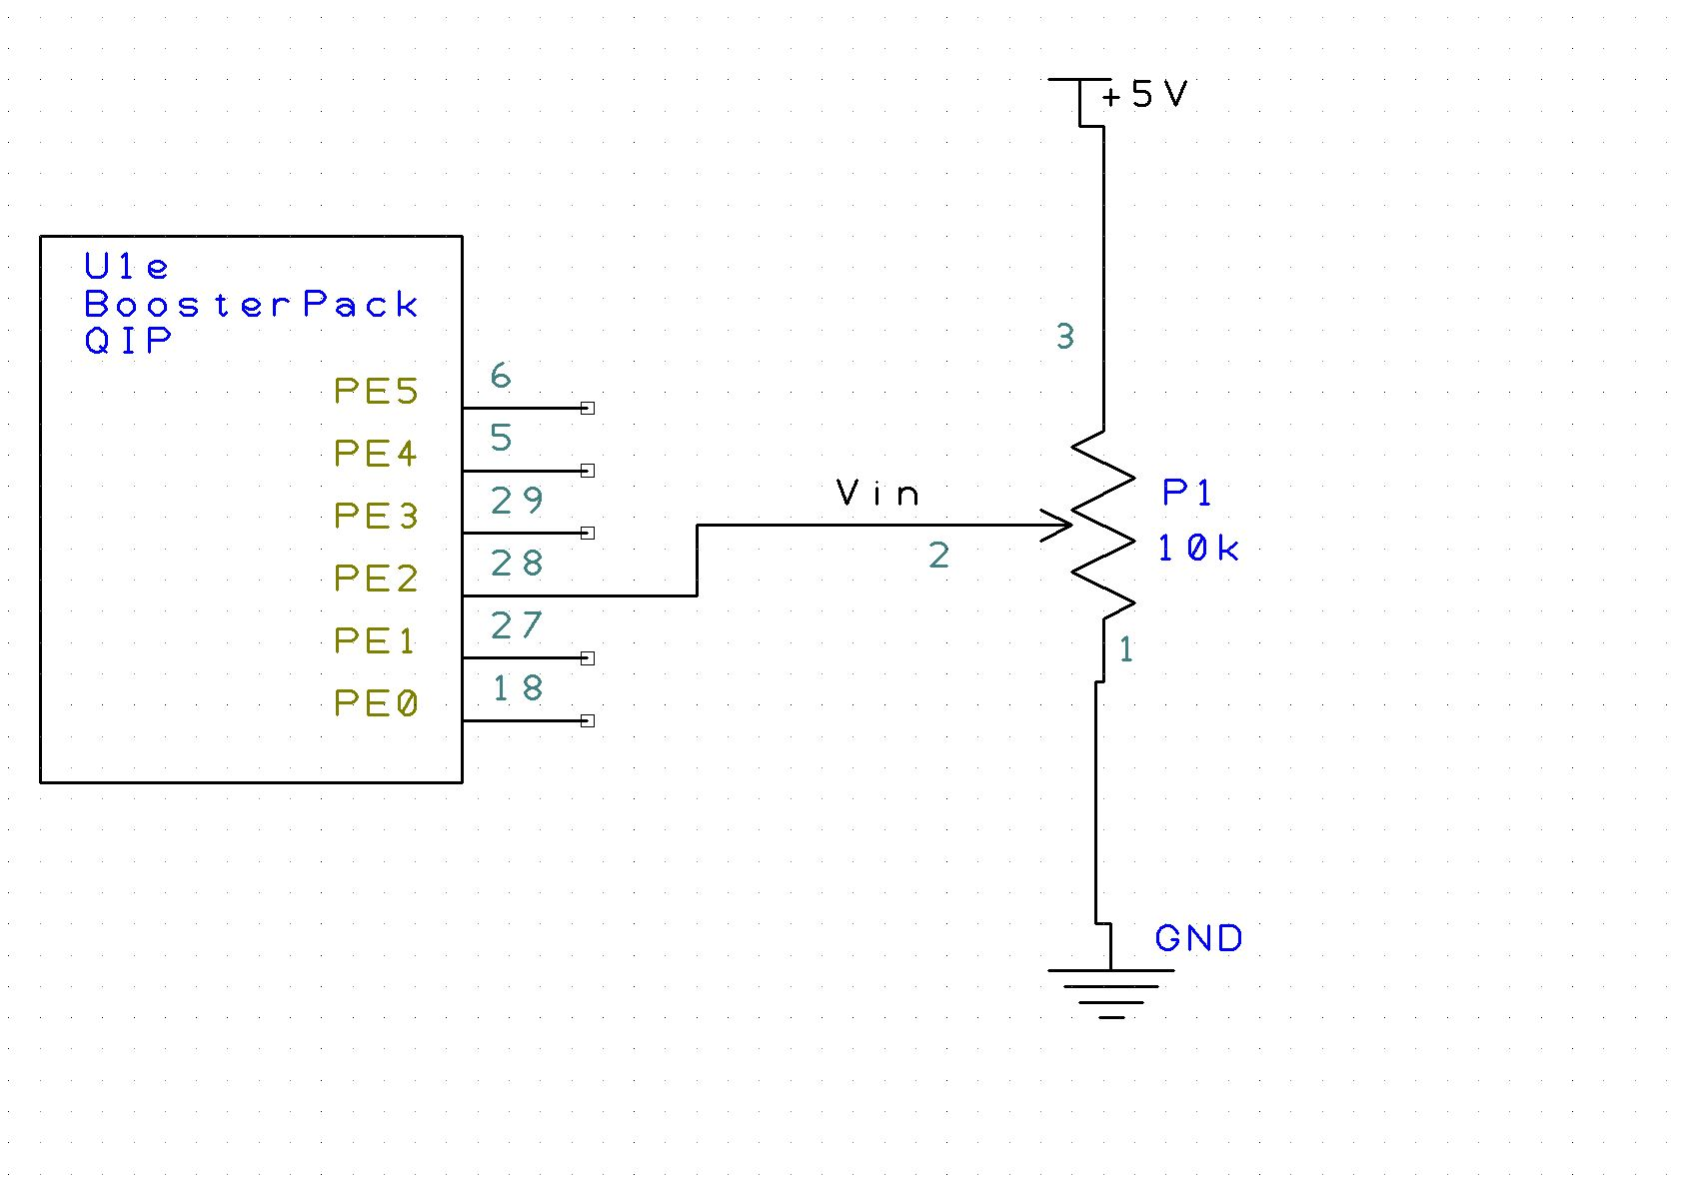

Potentiometer

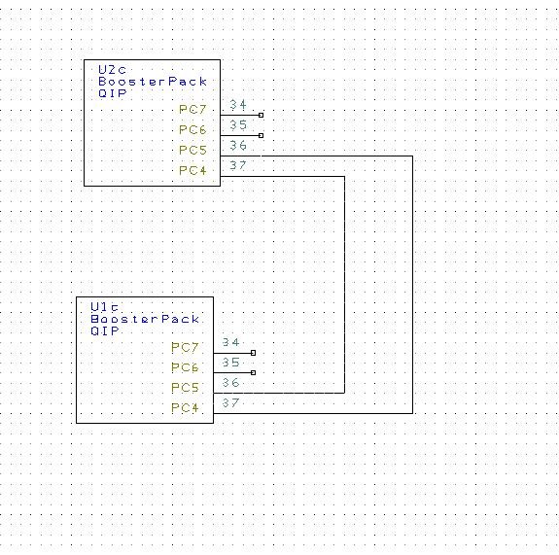

UART transmit and receive connections